## **📘 User Manual: Tech Titans Learning Platform**

### **1. 🌟 Introduction**

Welcome to **Tech Titans Learning Platform**, your gateway to unlocking knowledge and building skills. This guide provides step-by-step instructions to help you navigate the platform, complete lessons, track progress, and ace quizzes.

### **2. 🚀 Getting Started**

#### **Step 1: Logging In**

1. Launch the app and tap on **"Continue with Google"**.  
   *(Refer to Fig. 1 below)*

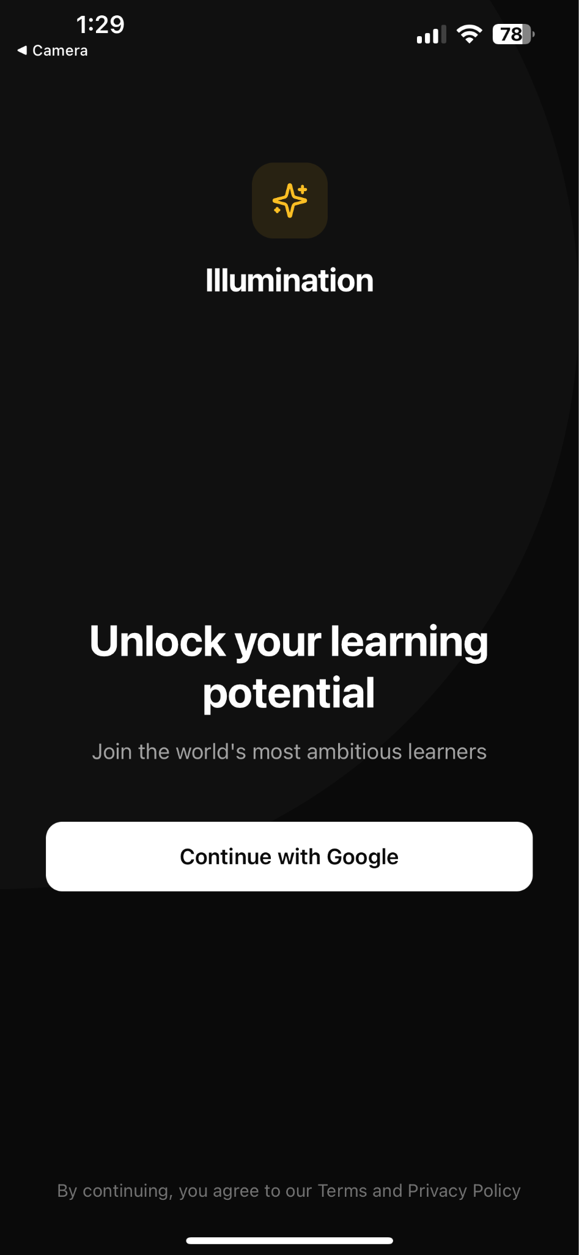

1. Ensure you use your authenticated Google account for smooth access.

#### **Step 2: Dashboard Overview**

After logging in, your **dashboard** (Fig. 2) provides a snapshot of:

* Your **XP Points** and **Current Streak** 🔥.
* Recently attempted quizzes and featured articles.

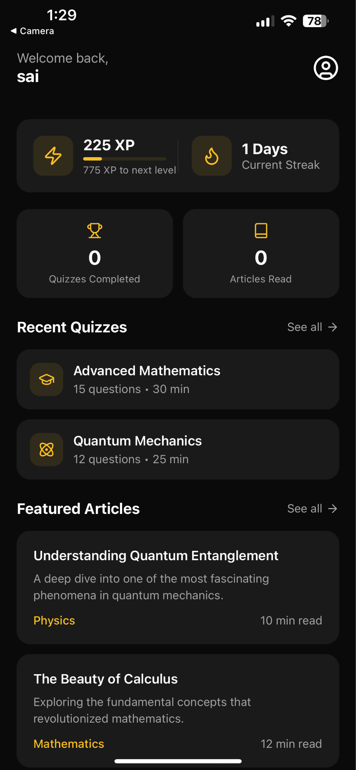

### **3. 📚 Exploring Lessons**

#### **Step 1: Access Topics**

1. Navigate to the **"Lessons"** section.
2. Browse through topics such as Physics and Mathematics.  
   Example: Select the topic **"Introduction to Physics"** (Fig. 3).

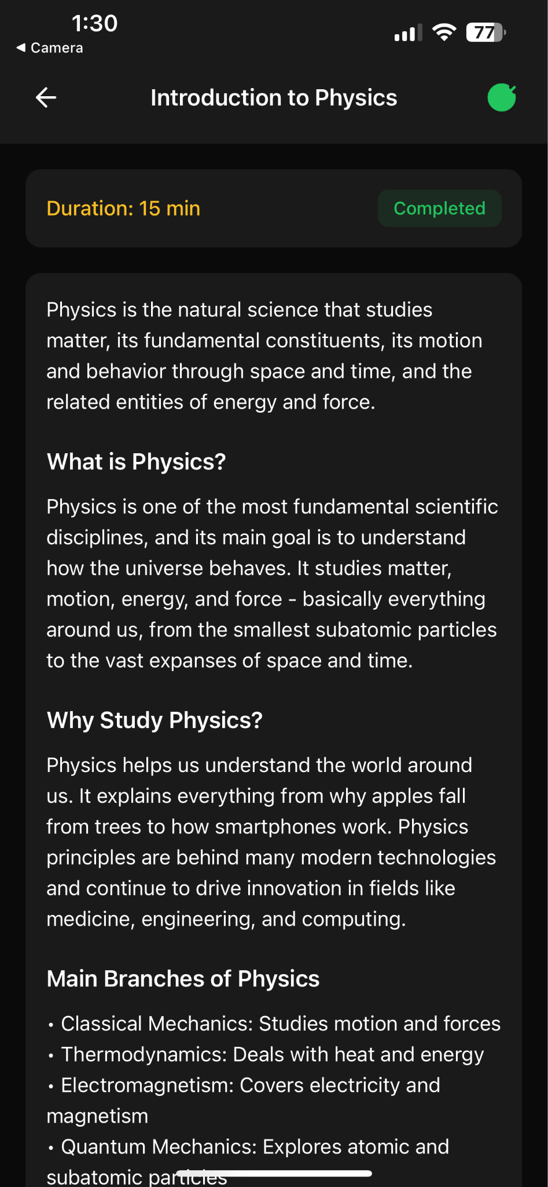

#### **Step 2: Complete a Lesson**

1. Each lesson provides:
   * An overview of the topic.
   * Estimated duration (e.g., **15 minutes** 🕒).
2. Once you finish, tap **"Mark as Complete"** to track your progress.

### **4. 🧠 Attempting Quizzes**

#### **Step 1: Access Quizzes**

1. Go to the **"Quizzes"** section in your dashboard.
2. Select a quiz, e.g., **"Advanced Mathematics"**.

#### **Step 2: Answer Questions**

1. Respond to each question, and submit answers.
2. Feedback is provided instantly:
   * **Correct answers**: Highlighted in **green** ✅ (Fig. 4).
   * **Incorrect answers**: Highlighted in **red** ❌, with explanations.
3. **Example Questions:**
   * **What is the derivative of exe^xex?** (Fig. 5).

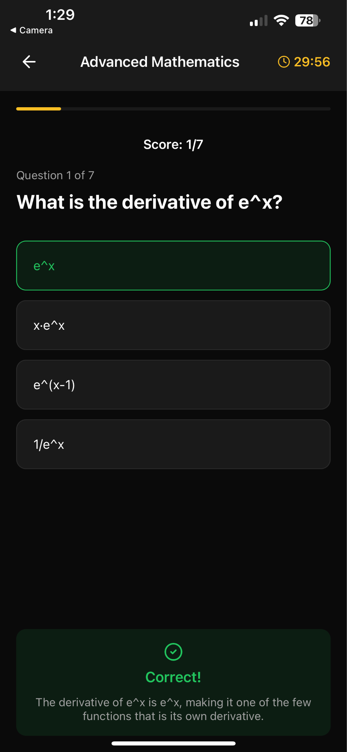

### **5. 📈 Tracking Your Progress**

#### **View Progress Dashboard**

Access a comprehensive view of your achievements via the **Progress Dashboard**

* Track:
  + Completed lessons.
  + XP Earned 💪.
  + Streaks 🔥.

### **6. ✨ Featured Articles**

#### **Access and Read Articles**

Discover insightful articles tailored to your learning goals (Fig. 7):

* Example:
  + **"Understanding Quantum Entanglement"** (Physics).
  + **"The Beauty of Prime Numbers"** (Mathematics).

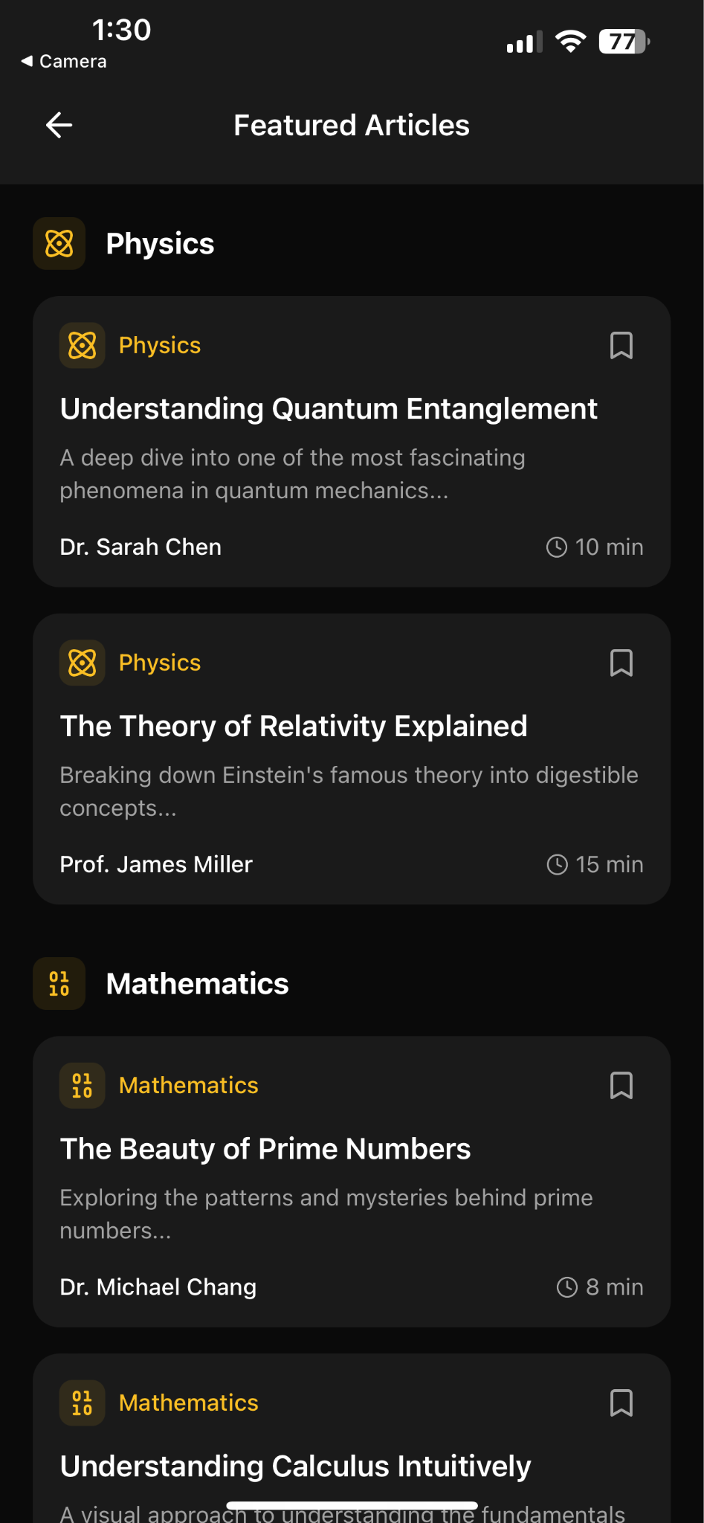

### **7. 🔧 Advanced Features for Developers**

#### **API Access**

For developers, the platform offers an API with the following key features:

* **Base URL:** <https://your-domain.com/api>
* **Endpoints:**
  + GET /topics – Fetch all topics.
  + GET /quizzes – Retrieve quizzes.
  + POST /submit-quiz – Submit quiz answers.

### **8. 🛠 Support and Feedback**

We’re here to help! For support or suggestions:

* 📧 Email: **support@tech-titans.com**
* 💬 GitHub: [Submit an Issue](https://github.com/htmw/2024F-Tech-Titans/issues)